Bios 737 Homework 1

Hannah Waddel

September 3, 2019

## Problem 1

Within a plot of land, we have data on the locations of diseased and healthy myrtle trees. We are interested in determining whether the spatial distribution of the diseased and healthy myrtle trees is the same. Any significant differences in the spatial distribution of the trees may give us insight into causes behind the diseased or healthy condition of the trees.

The first analysis was to determine whether or not the myrtle trees are distributed according to complete spatial randomness. Pielou’s statistic was calculated for the data and Monte Carlo simulation was used to compare the Pielou statistic for all myrtle trees, healthy myrtle trees, and diseased myrtle trees to CSR data.

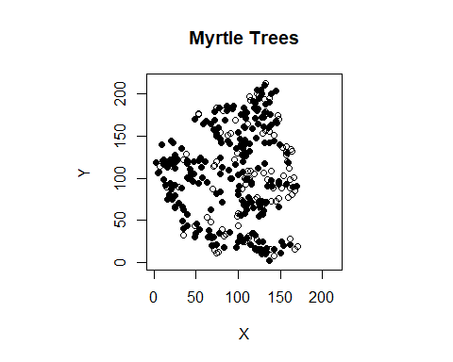

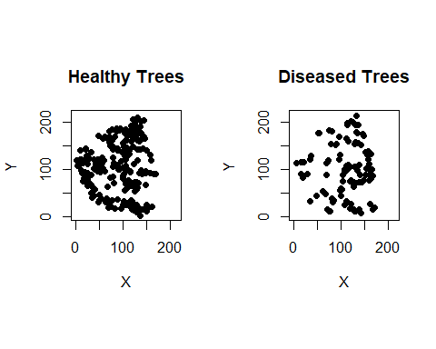

"Pielou's Statistic for all trees, calculated by hand: 0.657"

"Pielou's Statistic for all trees, calculated using csrplus: 5.042"

"Pielou's statistic for healthy myrtles, calculated by hand: 0.658"

"Pielou's statistic for healthy myrtles, calculated with csrplus: 4.395"

"Pielou's statistic for diseased myrtles, calculated by hand: 0.507"

"Pielou's statistic for diseased myrtles, calculated using csrplus: 1.863"

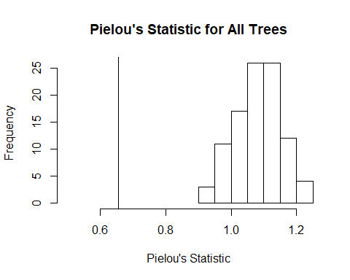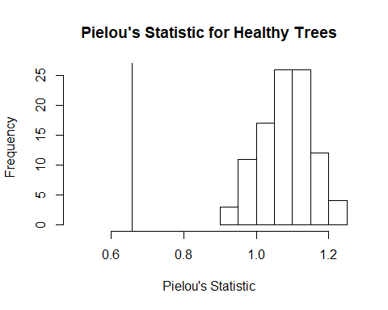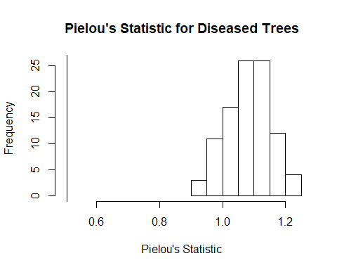

I am getting different answers calculating Pielou’s statistic by hand versus using csrplus. I think this may be due to the way csrplus calculates Pielou’s statistic (with a sample of points instead of events). For the rest of this analysis I will calculate Pielou’s statistic by hand.

With a Monte Carlo p-value of 0.01, there is evidence to suggest that the myrtle trees do not follow a CSR distribution. Pielou’s statistic for the observed data is less than the simulated CSR Pielou statistics, suggesting that we are observing some clustering in our data.

## Problem 2

Within the Black Mesa area, we have data on the locations of 490 Anasazi settlements. Settlements are classified as old settlements if they were dated between 850 and 949 A.D. or new settlements if they were dated between 950 and 1050 A.D. We are interested in examining the spatial distribution of these settlements.

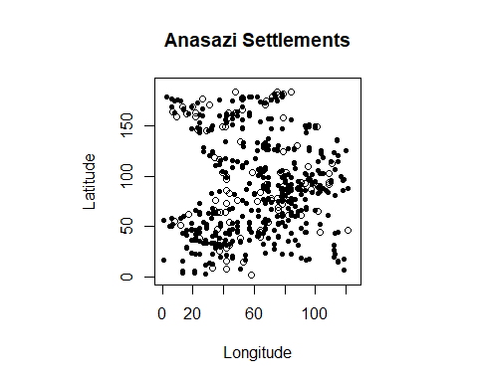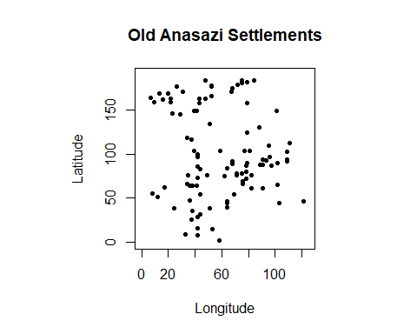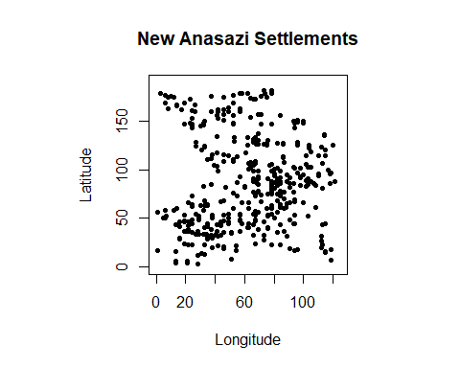

The first analysis was to determine whether or not the settlements follow a complete spatial random (CSR) distribution. To determine this, we used Pielou’s statistic as our test statistic and Monte Carlo simulation to obtain p-values.

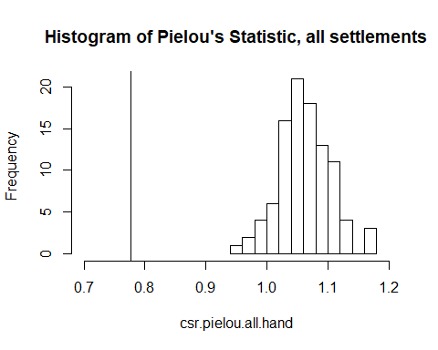

"Monte Carlo P-Value, All Settlements: 0.01"

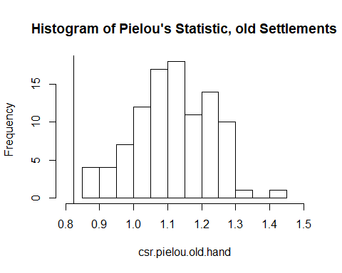

"Monte Carlo P-Value, Old Settlements: 0.01"

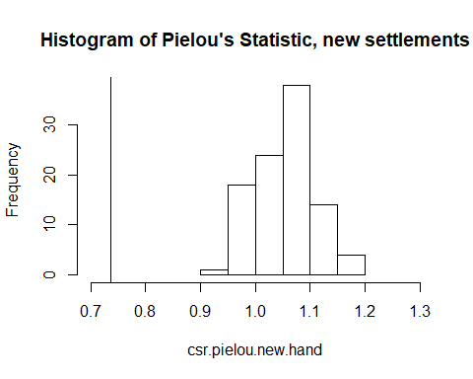

"Monte Carlo P-Value, New Settlements: 0.01"

With Monte Carlo p < 0.05 for each group, there is evidence to suggest that all the settlements, old settlements, and new settlements do not follow a CSR distribution. Because the observed Pielou statistics are generally less than the simulated CSR Pielou statistics, this suggests that there is some clustering of settlements in our data.